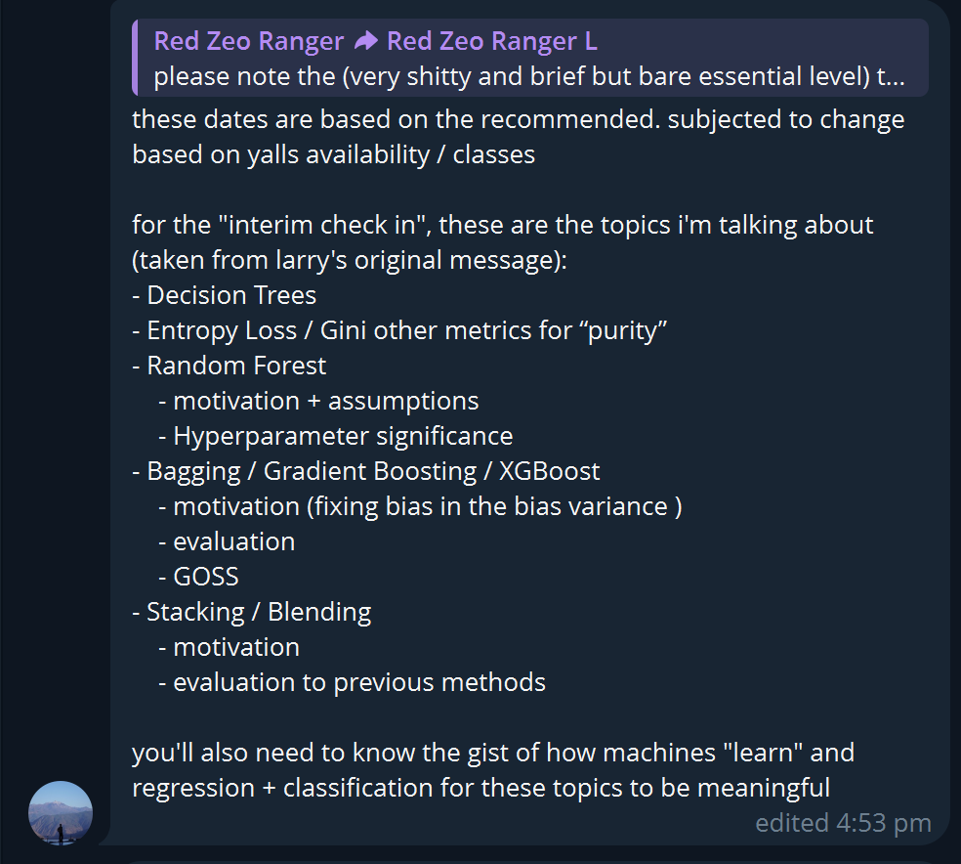
Ensemble Learning
Decision Tree 1
Entropy Loss / Gini other metrics for “purity” 4
Entropy Loss 5
Gini other metrics for “purity” 5
Random Forest 4
Motivation + Assumptions 5
Hyperparameter significance 5
Bagging/ Gradient Boosting/ XGBoost 4
Bagging 5
Gradient Boosting 5
XGBoost 5
Stacking / Blending 4
Motivation 5
Evaluation to previous method 5
What is Ensemble learning
Ensemble learning is when multiple weak models come together and combine to produce a weak model
To understand ensemble learning we need to start off with a base learner, which begins with decision trees.
1. Basics of Ensemble Learning
Using a single ML model is NOT always sufficient to achieve accurate predictions
- ML models face the problem of overfitting and underfitting when undergoing training
- In ensemble learning, single models = weak models. WHY? They are prone to..
● High bias: underfitting (cannot capture data trends well)
● High variance: overfitting (model is too complicated, cannot generalise well on test data)
3 ways to make final predictions from your ensemble learning model
1. Max voting: usually for classification problem, take the prediction from the majority of weak learners
2. Averaging: usually for regression problems, take the average of all values predicted from the weak learners
3. Weighted average: same as averaging - but you assign each model a different weight based on the importance of the prediction of that model

Decision trees (The foundation)
Everything begins with decision trees because:
- They are simple and interpretable
- They are weak learners
- Ensembling fixes the weakness of trees
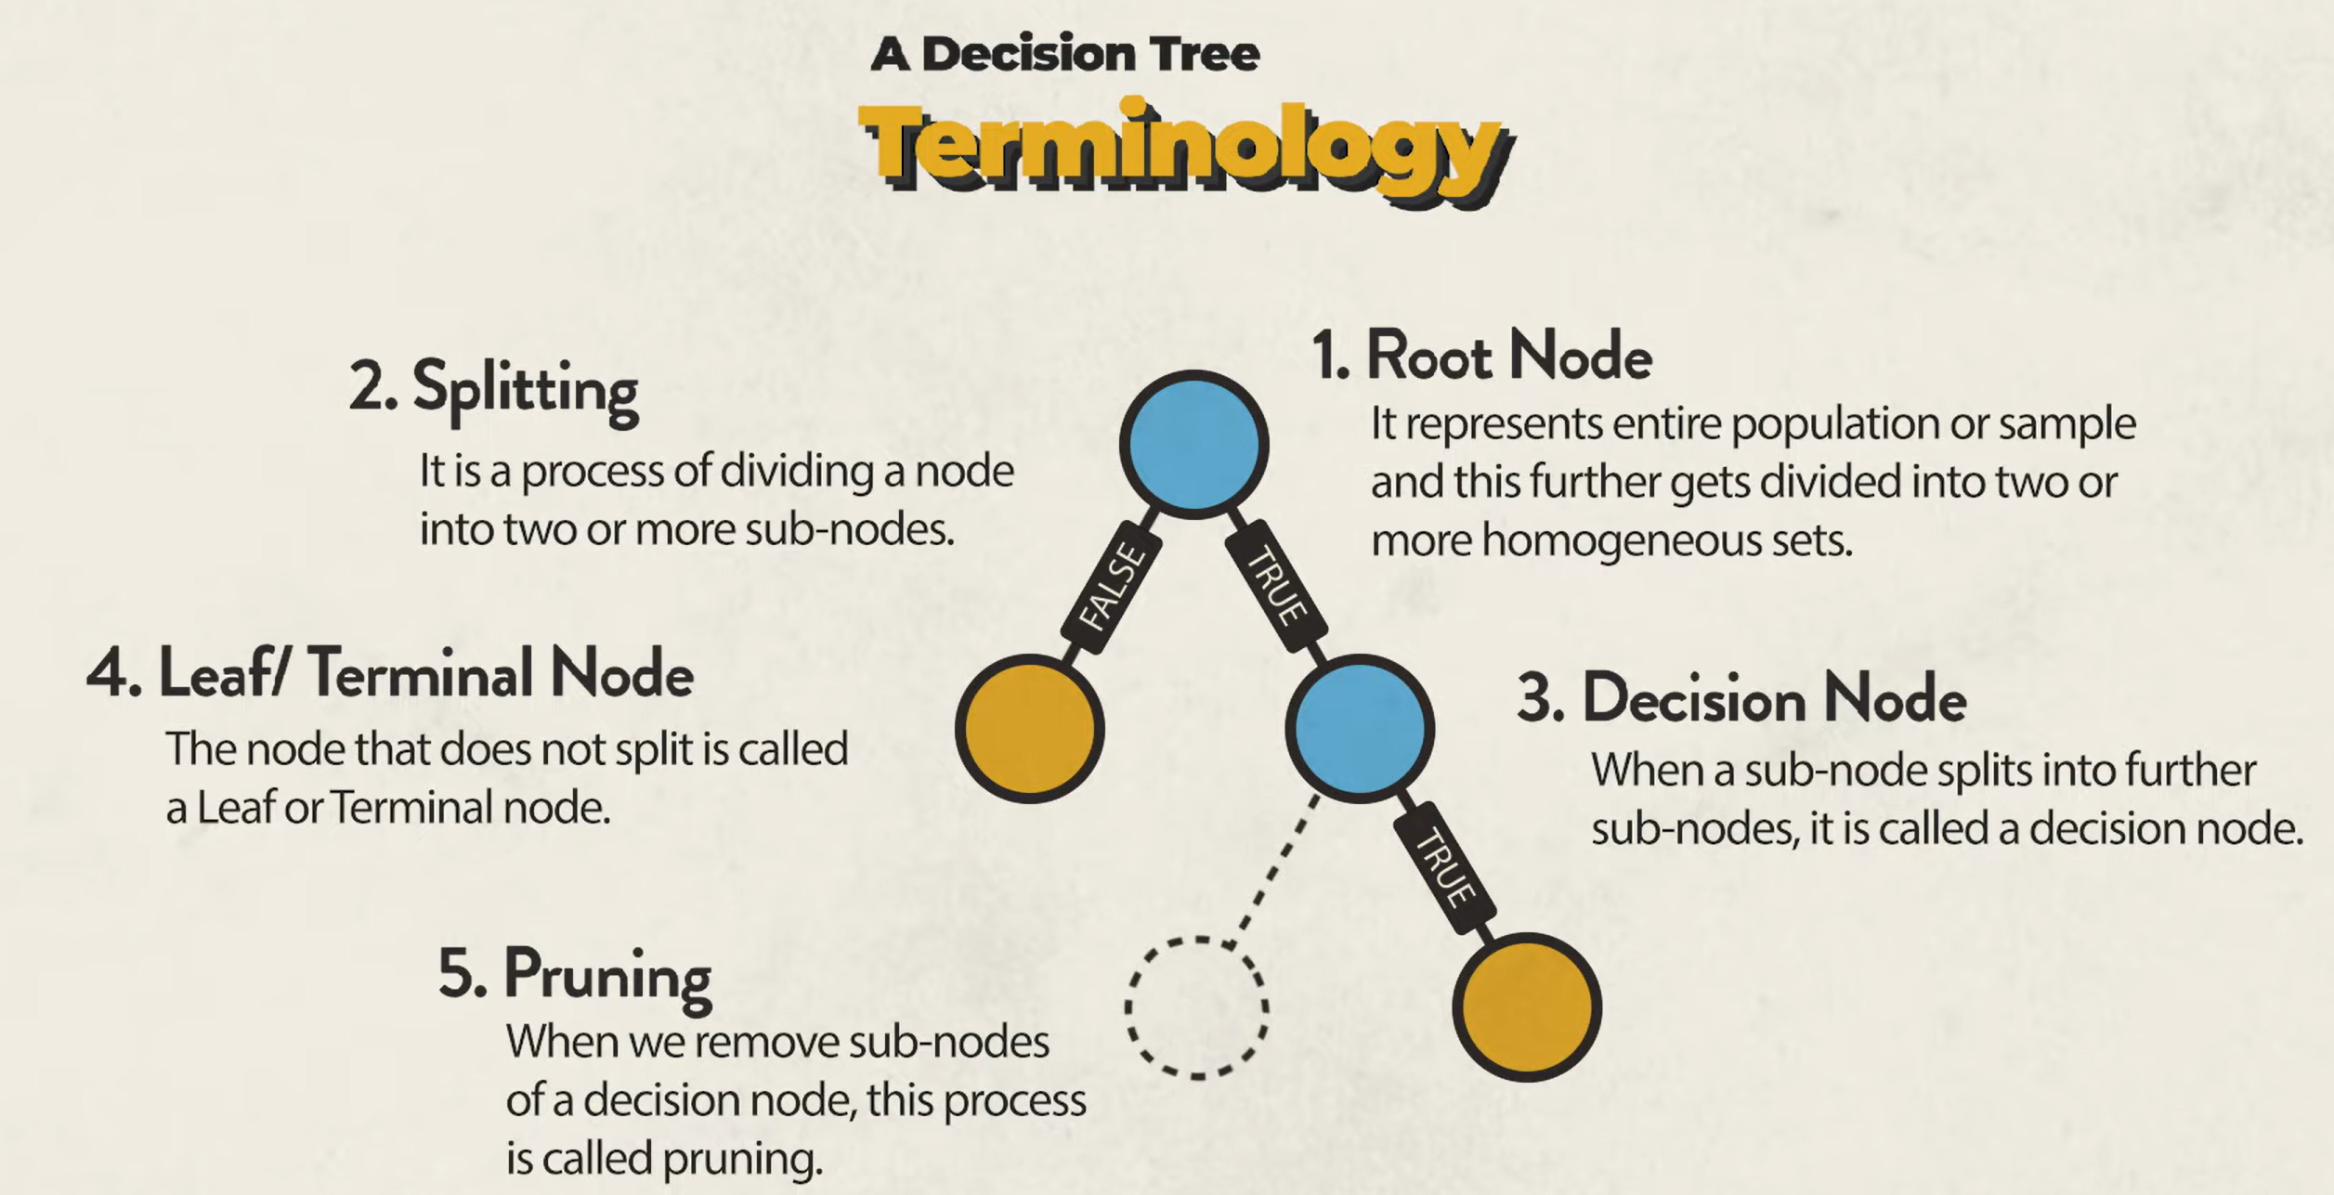
Root Node – Represents the input population (everyone)
Splitting – Process of taking a population and dividing them on a condition
Decision Node – The resultant of splitting
Leaf/Terminal Node – Will not go through splitting any further or because it is pure.
Pruning – Removing sub-nodes of decision node. Used to avoid overfitting.

There are many Ensemble methods, and each have their own characteristics
Methods |  | Trees | Why?
Bagging |  | Yes | Trees overfit; Bagging reduces variance.
Random forest |  | Yes | Adds randomness to improve bagging.
Gradient Boosting |  | Yes | Trees learn residuals stage-by-stage
XGBoosting |  | Yes | Optimised boosting implementation
Stacking/Blending |  | Often Yes | Trees complement other models.
Entropy Loss and Gini other metrics for purity
Entropy loss
Entropy measures the level of disorder and reanodmness in a system. In data scinenc and ML, entropy of a variable is the average uncertainty inherent to the possible outcomes and is the measure of a certain event.
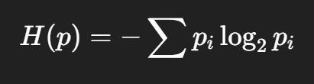
The loss of entropy after splitting is not Entropy Loss, instead its called Information Gain.
Formula 1
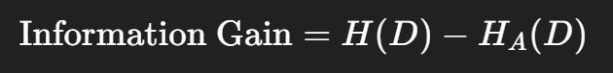
Formula 2
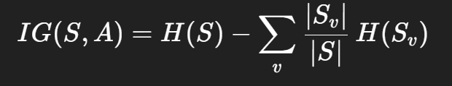
Where,
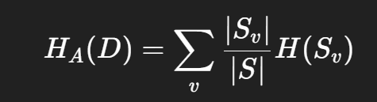
What do they all mean?
Information gain is the parent entropy minus the weighted sum of child entropies.
H(D) is entropy of the parent node and HA(D) is the weighted average entropy of all child nodes split from D on attribute A.
HA(D) is the weighted average entropy, it pretty much means u take the entropy of one system, multiplied by how much of subset sample it inherits from its parents. Then sum up all the child’s weighted entropy. The diff is the information gain

Cross Entropy
We move from trees to models that ouput probabilities.
entropy measures how uncertain events are, cross entropy measure how much prediction matches the truth
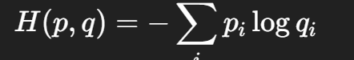
Where p and q are the the true distribution and q is the predicted distribution. This cross entropy encapsulates entropy while including error penalty
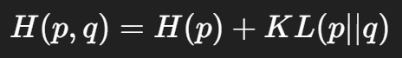
Where KL is the penalty for being wrong
Cross entropy loss
In classification models, true labels are one-hot vectors:
- If class k is correct: $p_{k}=1$
- All others: $p_{i}=0$
So cross-entropy becomes:
$$L=-log⁡q_{\text{true class}}$$
This is the loss function used in:
- Logistic regression
- Neural networks (softmax classifiers)
- Gradient boosting for classification
- Deep learning everywhere
Meaning:
- Penalizes confident wrong predictions
- Reward confident correct predictions
- Produces smooth gradients
- Aligns with maximum likelihood estimation
Cross-entropy measures model error, not impurity.

Gini Other metrics for purity
Gini Impurity
Gini Impurity is a measurement used to build Decision Trees to determine how the features of a dataset should split nodes to form the tree. More precisely, the Gini Impurity of a dataset is a number between 0-1, which indicates the likelihood of new, random data being misclassified if it were given a random class label according to the class distribution in the dataset.
The formula for Gini Impurity is as follows:
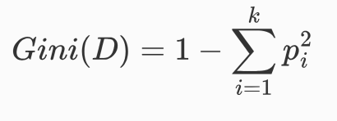
Where D is the node you are at, p is the probability of a class in k classes.
Gini Purity is the summation of (probabilities of classes) ^2. Gini Impurity is just 1 – Gini Purity.
It is to mention that 0-1 range might be misleading. For Bi-Classification(k =2), Gini Impurity maximum is 0.5 (1-1/k=2), and as k increases, the Gini impurity maximum increases following 1-1/k. In practice, gini impurity never approaches one. `If Gini impurity is very close to one, it just means its very diverse and more evenly spread. A low gini impurity means, one class dominates.
In a way, gini impurity is measure of eveness between classes and number of classes.
Now lets say this node goes through splitting into 2 more nodes, Node D1 and NodeD2.
When there is splitting, there is a chance that there is a change in the Gini impurity from D to D1 or to D2. This is gauged by the weighted average impurity after splitting on attribute A.
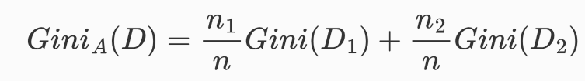
Here there, Node D is split based on attribute A into D1 and D2, with sizes n1 and n2. The Weighted average impurity from D to D1 and D2 is GiniA(D). The decision tree at a node decides to split on whatever attribute based on the smallest weighted average impurity.
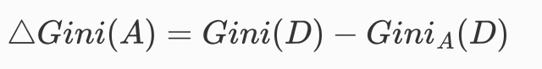
Here we Gini(A) is the Gini gain, if its big positive, the this means it helps to make the child nodes more pure (less impure). If its small or negative, it means the splitting on attribute A does not help with the purity.
It is to be noted, each tree is trying to sort on each node locally, they do not compute the globally best tree because the search space is too large.
Classification Error Rate
Random Forrest
Pros: Reduces Overfitting
Reduces Bias
Robust to noisy data
More Stable than a single decision Tree.

To set up a random forest, you must set parameters, node size, no of trees and no of parameters.
You want many trees run simultaneously to get a better aggregated average but not too many to be computationally intensive.
What does it actually do? Imagine you have a dilemma, then you consult a bunch of people to decide on the matter. They each give you, their opinion. Each of them had their own way of deciding what was the best solution. You conduct a survey and you try to conclude the overall best solution based the number of shared opinions.
A high-level description of this explanation would be is each person is also introduced to a different random subset of data related to this dilemma and are given a different random subset of features. This would lead to people having different thinking processes and thus a stand as a different decision tree.
What is the mechanism behind Random Forrest?
Overall Main Mechanism:
Bootstrap Sampling:
Each tree is given its own training set, created by random sampling from the original data with replacement. This means some data points may appear multiple times while others aren’t used.
Random Feature Selectrion:
When making a split each tree only considers a random subset of features (typically a square root of total features)
Growing Trees:
Each tree grows using its own bootstrap sample and selected features making splits until it reaches a stopping point (like pure groups or minimum sample size)
Final Prediction:
All trees vote together for final prediction. For classification, take the majority vote of class predictions; for regression average the predicted values from all trees.

Math behind Random Forrest:
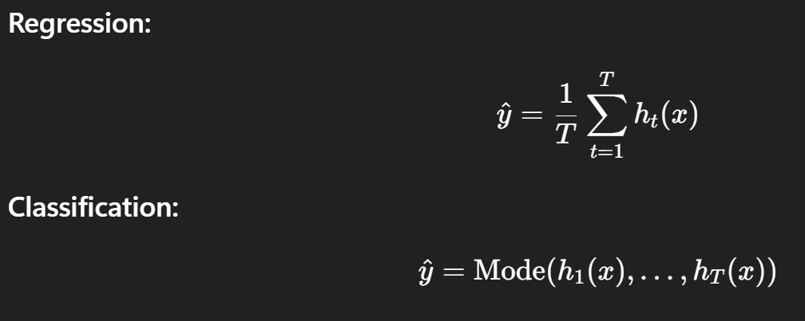
When is Random forrest a regression problem or a classification problem?
It boils down to what it is being used to solve and the output of a tree. If the output is going to be a predetermined set of answers or a label: likely to be a classification problem, if its going to be a number: it’s a regression problem
What is the random forrest trying to eliminate:
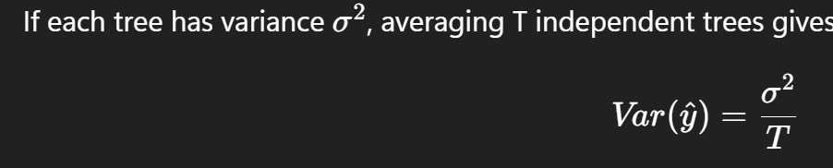
Random Forrest is trying to average this thing called noise. It’s inaccuracy of depending on a tree. Why is one major tree alone is inaccurate, the one tree runs on the entire set of data and is prone to overfitting. The tree will not do learning but resort to memorising training data, it will grow too deep, a slight change in data will result in arguably different outcome and would thus have high variance.
Whereas random Forrest relies on a parallel series of trees where each have a unique subset of data. Data used for a single tree can be obtained is prone to human error, measurement error, outliers, missing values, random chance and unpredictable variations. This all contribute to why prediction based on a single tree will differ from the actual event. When we use multiple trees, this noise is cancelled out. The averaging of these trees produces a more reliable prediction.

